

PROJECT

PASSWORD LOCK SYSTEM

Abdullah Ghaleb (1713177) Mechatronics

LECTURERS: Dr.Yasir & Dr.Hazlina

DATE OF SUBMISSION: 25/1/2021

SEMESTER 1 20/21

SECTION 1

DEPARTMENT OF MECHATRONICS ENGINEERING

INTERNATIONAL ISLAMIC UNIVERSITY OF MALAYSIA

Objective:

This project simulates the password security system that is used in many real life applications for example, money locker , ATM pin security and many more . So it is a security system that save valuable items and locks them with the most secure method which is password, Main goal is to build a system to secure the personal valuable stuff with a password.

Design process

Every security system has a special way to unlock , password is one of the securest methods to lock and unlock systems. By using logic gates such as AND,OR,XOR and so on it is possible to build this project. all we need is inputs which represent as number buttons in my project i add 10 input for user to unlock and 10 for set/reset the password and using 10 XOR with inverter for each gates or XNOR is possible to use . known that XNOR truth table is said that if there is 2 inputs has same value the output will be 1 like the table below :

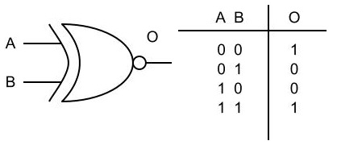

Therefore, by connecting first 10 input to the A terminals in XNOR gates and second 10 inputs in B terminals , the system will compare the first 10 numbers with second 10 number if they are same it will unlock the system after that i am using 5 AND gates and that to check if all output coming from XNOR gates are high and that because AND gate has multiplication operation thus will only accept when all input are high below is the truth table of AND gate :

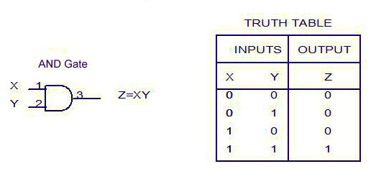

Lastly all outputs of 5 AND gates will be connected to in AND gate to double check the values and give output of two other AND gates if it is satisfied then will unlock the system if not it will go to inverter to keep lock the system , both AND gates are connected to constant which has role of switching the system.

Design :

Logisim logic circuit :

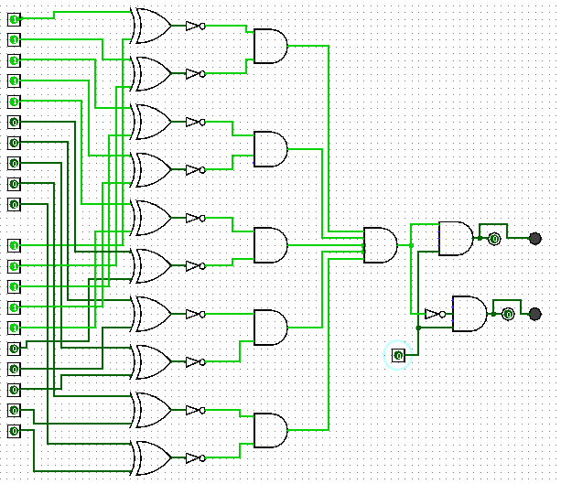

Truth table

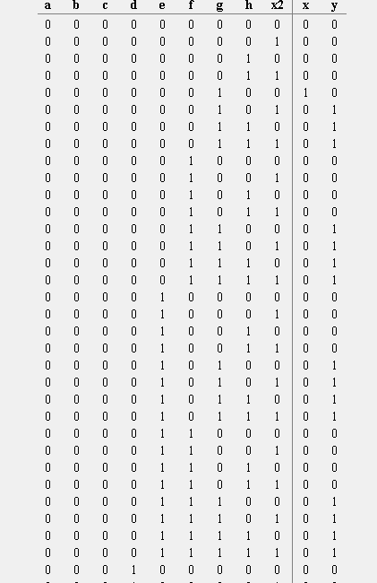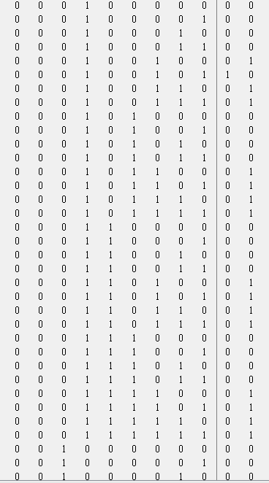

Multisim verification :

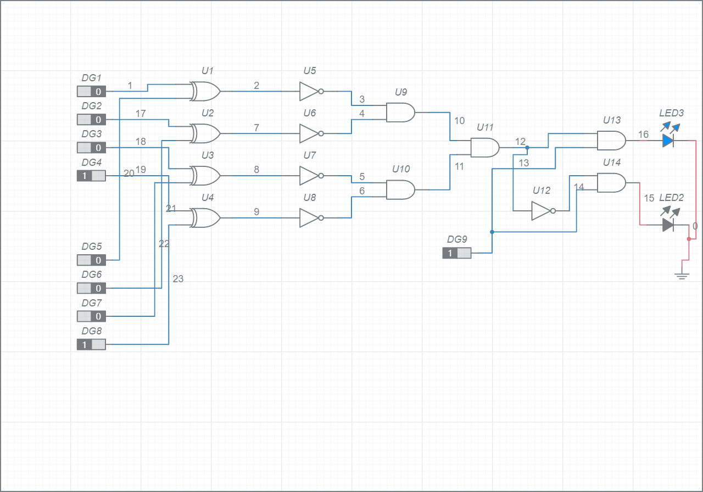

Conclusion :

Lock system application is very important in many different fields. We always use it in our phone ATM machines and mail boxes . By logic gates it can simply be implemented with easy wiring.